Thesis outline

Title: X-ray spectroscopies of warm dense matter

1. **Introduction**
   1. Physics of WDM
      1. contrast to plasma and solid state regimes (in terms of fermi degeneracy and coulomb interaction strength) **Fig. 1, atlas of high-energy density physics**
      2. Summary of the theoretical/experimental challenges (failure of perturbative treatments, lack of LTE, continuum lowering, what else?) **Fig. 2 from Ciricosta paper on IPD experiment at LCLS and comparison to modeling approaches.**
   2. Scientific applications
      1. Modeling gas giant core/mantle conditions **Fig. 3 from Wilson et al., simulation of MgO solubility at gas giant core/mantle boundary.**
      2. Inertial confinement fusion **Fig. 4, cartoon of indirect-drive ICF. Connect to the difficulties of equation of state modeling.**
   3. Experimental generation of WDM
      1. (long pulse) ramp and shock compression. Associated diagnostics: XAFS with broadband backlighter (**Fig. 5**: **Yaakobi plot showing EXAFS for a shock-induced phase of iron).** Branching ratio measurements (**Fig. 6: Nilson Cu studies at LLE),** XRD measurements (**Fig. 7: Ma et al Al XRD).** VISAR (**Fig. 8: Lee 2006)** and relationship to hydrodynamic modeling of shock compression. Discuss what physics all of these techniques interrogate, and their limitations.
      2. Short (fsec) pulse heating. Applications: generation of x-rays; particle acceleration. How much science is there that’s unique to this time scale? (from the point of view of bulk properties not much changes between ps and fsec time scale, due to the slow coupling of energy from MeV into the solid). Need to do more reading.
      3. XFEL heating. How much should I put here? This section should contain a subset of the background section in chapter 4.
   4. X-ray diagnostics of WDM
      1. Why X rays?: optical probes fail due to high opacity
      2. Summary of techniques: XRTS, XES, XRF, XRD, and SAXS. XRF and XRD have already been introduced. Not sure if there exists prior work with SAXS and WDM, but I should still point out the technique’s existence. Need to talk about XRTS and its use as a tool for inferring density and temperature. Two components: Compton scattering and plasmon oscillations (**Fig. 9: Lee wide-q range XRTS; Fig. 10: Kritcher et al. cartoon of XRTS experimental setup for measurement of plasmon oscillations at a laser plasma facility).** Discuss difficulties of modeling-based inference of temperature/density using Compton scattering (cite Mattern).
   5. Summary of thesis content
2. **A photometric study of energy-dispersive X-ray diffraction at a laser plasma facility** (Hoidn and Seidler, PoP)
3. **Nonlocal heat transport and improved target design for X-ray heating studies at x-ray free electron lasers**
   1. Physics of PENELOPE
      1. Overview
      2. Overall description of PENELOPE
   2. Types of interactions
      1. Scattering
      2. Fluorescence
      3. Auger
   3. Numerical implementation
      1. PENELOPE internals
      2. Coarse-graining
   4. Accuracy and useful regimes
      1. Model validity: PENELOPE’s elastic and inelastic DCSs become unreliable below 1 keV
      2. Bounds on simulation accuracy:
         1. CSDA range for 1 keV electrons (approx. 10 nm)
         2. Up to 20% deviation in DCS between 1-10 keV. (How do we numerically propagate this to uncertainty in energy deposition density distribution?)
      3. Bulk/nano issues: calculation of DCSs derived from bulk dielectric functions is problematic in the current setting, where target nanostructures can alter plasmon spectrum.
         1. Problem for modeling the spatial distribution of deposited energy at and below the 10 nm scale
         2. But also a research opportunity for future studies of finite-T electronic structure, to the extent that predicted short-range stopping power differs between models.
   5. Simulation results (**HEF paper**)
4. **WDM studies at the LCLS**
   1. XFELs
      1. The physics of XFEL
      2. XFEL as a tool for producing and characterizing WDM.
         1. primary advantages:
            1. short accessible timescale
            2. ability to do two-color pump-probe
   2. Scientific case for studying WDM at the XFEL
      1. Early XFEL heating studies:
         1. Bostedt et al ultrafast ionization of clusters
         2. Young et al. hollow neon atoms
         3. Nagler et al. Al
      2. Understanding the onset of electronic heating and (thermal or nonthermal) lattice deformation in x-ray heated solid state systems. One of the basic questions is that of the time scales involved in each constituent process of the relaxation cascade.
      3. Revisit certain suggestive, but ambiguous, experimental results in the existing literature using higher-information diagnostics (for example, Hau Riege’s observation of possible nonthermal melting in graphite).
      4. Testing models of finite-T electronic structure (WDC)
         1. Frozen-core finite-T produce interesting behavior in the valence electron contribution to simulated XRD signal.
         2. Short XFEL time scales make it possible to test these predictions.
   3. Design of an XFEL heating experiment:
      1. Diagnostics: XRD, specifically wide-angle XRD. Restate motivations given in the HEF paper.
      2. Tie into HEF target design
   4. Experimental results
      1. Lack of lattice thermalization in solid-state targets (Fe3O4 from LD67).
      2. Valence reorganization upon x-ray heating (LK20 MgO and Fe3O4)
      3. Time evolution of electronic reorganization (LK20 Fe3O4 long pulse vs. short pulse)
      4. Nonlocal heat transport: LD67 micro/nano Fe3O4.
      5. HEF qualitative result: SEM of clad/unclad LK20 mica samples.
      6. What else? Depends on outcome of analysis for LK20 graphite, HEF oxides.
5. **X-ray spectroscopy instrument development**
   1. A disposable x-ray camera based on mass produced CMOS sensors and SBCs (RSI paper)
   2. Camera software tools
      1. Overall architecture (block diagram + surrounding text)
      2. Event reconstruction
      3. python API for data collection/plotting
      4. summarize subsequent additions by Will
   3. A high resolution benchtop x-ray emission spectrometer for 2-2.5 keV (based on Holden et al. Minisoft paper)
6. **UW XAP: a real-time analysis tool for the LCLS.**

**Fig. 1**



**Fig. 2**

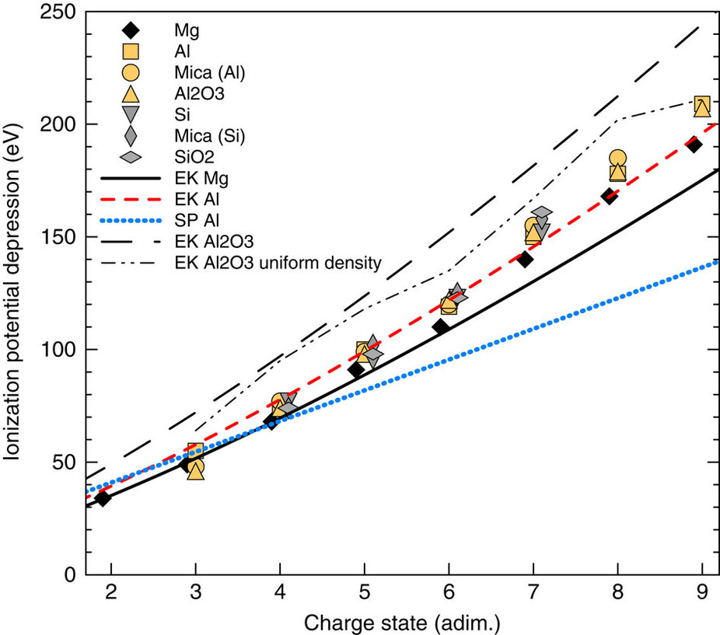

**Fig. 3**

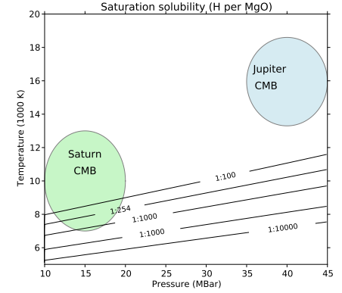

**Fig. 4**

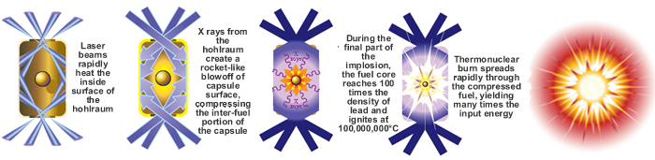

**Fig. 5**

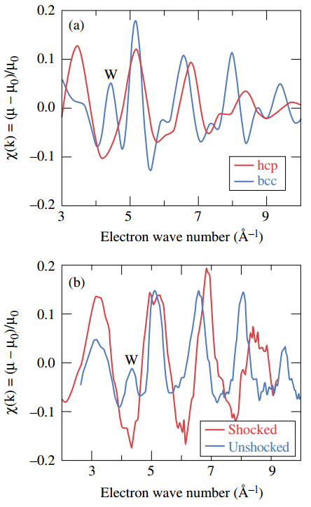

**Fig. 6**

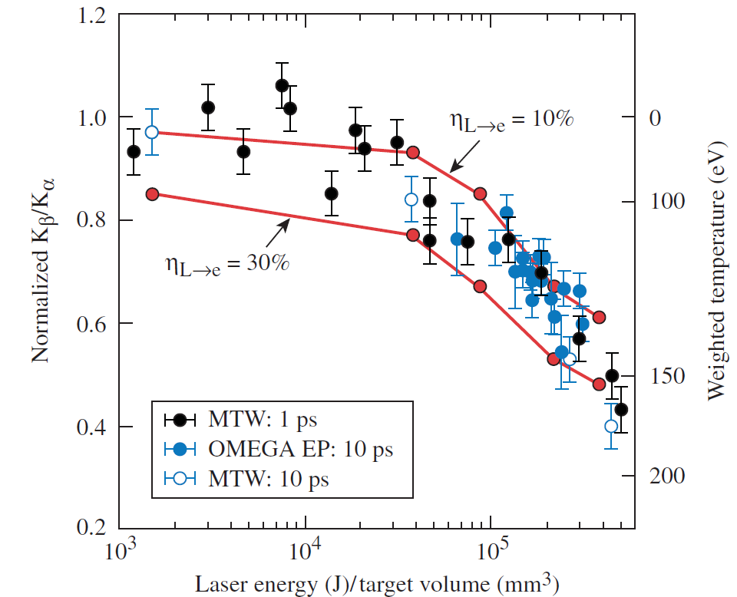

**Fig. 7**

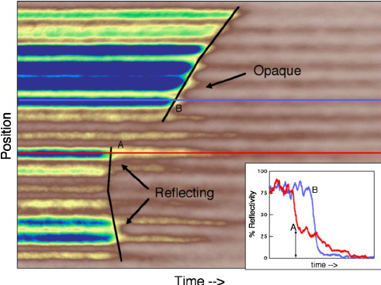

**Fig. 8**



**Fig. 10**

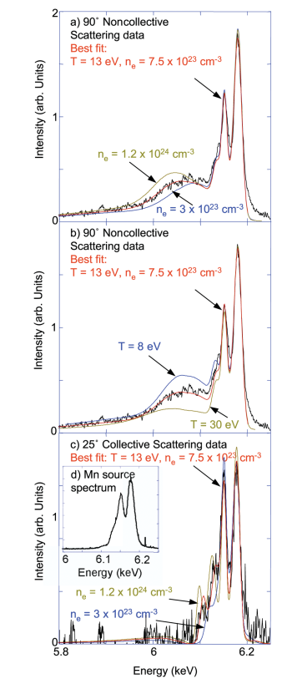

**Fig. 10**

